Hi All,

We are changing the software we are using for volunteering (mainly used for sail race volunteers of Race Officer, Assistant Race Officer, safter boat helm and crew.) Today we also have a warden page, but as we will have a new door which is automatically locked/unlocked, then warden duties will no longer be needed to sign up for – so we are not including those duties going forward. We may choose to include bar duties/galley duties and duties to help social events at some point, but initially, just sailing race duties will be used.
Starting in January we will be using a program called DutyMan. This system is open for anyone who is a member to use – you simply use your email address that is registered with HSC to log in. From the log in page, you can select one or multiple duties to volunteer for. You can also request to swap duties with someone specifically (if for example your plans change) or even register that you can no longer perform a duty and so open it up again for others.
Our club is run by volunteers, so even if you do not sail, we would still be very grateful for some time. Duties like assistant race officer, and crew would be directed by the relevant race officer, and safter boat helm – so no experience is necessary. You will find that even though they are called duties – they are great fun and offer a good way to become more integrated into our club, and to help meet new people – you may even discover that you would like to try sailing once involved

Loggin in
Go to this URL and log in. https://dutyman.biz/dm/H0002760
You can use mobile devices, tablets , and PCs – the actions are all the same. Initially you are asked for your email address. This is the same email address that you registered with us in membership and is used within Webcollect and asked to set a password – You do not need to do this. If you select not to put a password into the system, when you type your login email address, you will receive an email within a few seconds from DutyMan. Open that email, and select that you want to log into the system and you are in. If you do choose to set a password, you can input that to gain access. But its nice to have a system without a password for a change.

Selecting a duty
This is an example of how to volunteer as Race Officer on Sat 16th December.
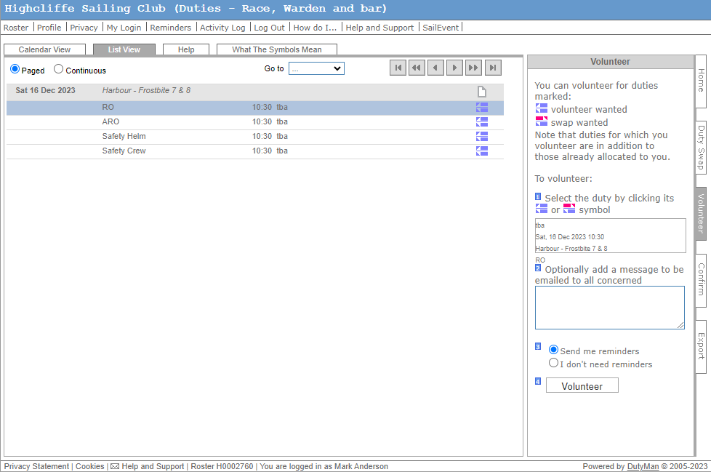
- Find the date you would like in the list
- Select the duty (in this case RO – Race Officer)
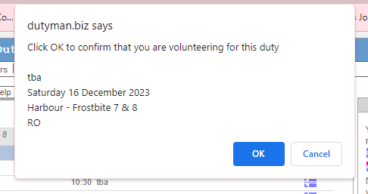
- This image pops up
- Selelct OK and you will see that your name is instantly added to the rosta like this:
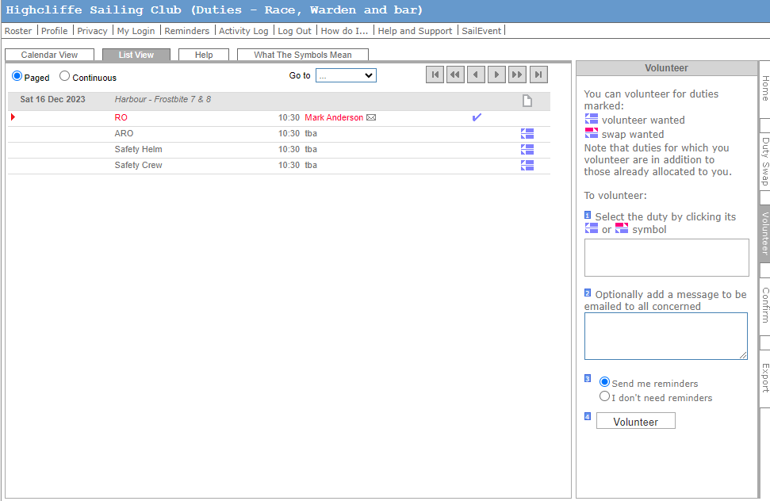

If you need to change your duty.
From time to time, other commitments come up and you may need to change your duty.

If you can no longer do your duty.
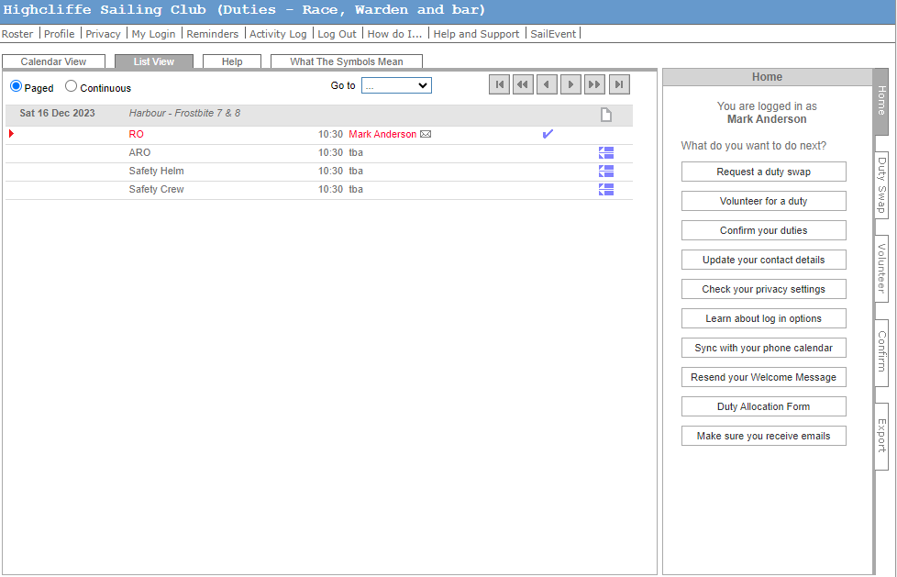
- Go to Roster tab, and find the duty – e.g. below
- Select the duty by clicking the red arrow here
- Then select ‘Cant Do’ Where you can type reason (eg illness, holiday etc) and the duty is relelased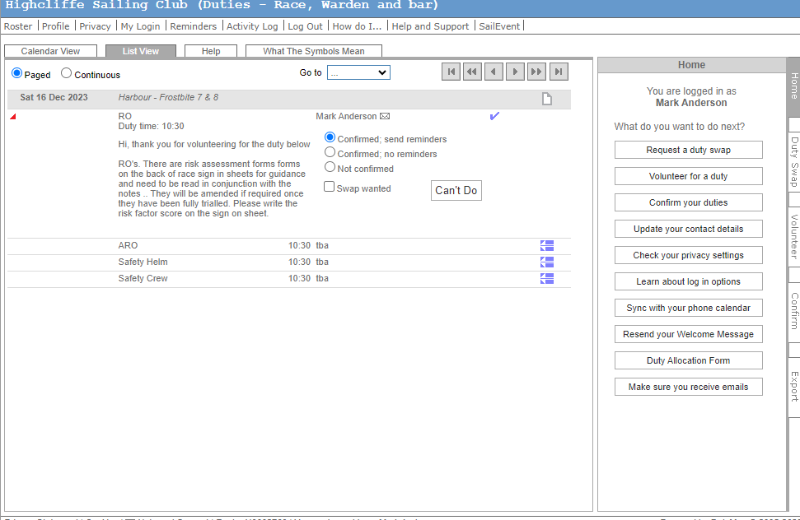
Alternatively if you would like to swap your duty – so as you cant do this one, but want to change for another date/time – you select and you are given a message to use the ‘swap tab’. Then when someone wants to swap, they request the swap and you are sent an alternative duty date to accept.
It is all pretty straight forward. My recommendation is to log in and try and learn as you go.

Best regards,

